Ex.No:3 | EXPLORATORY DATA ANALYSIS (EDA) – DATA CLEANING AND DATA TRANSFORMATION

AIM:
To identify and handle missing values, duplicate records, outliers, inconsistent data, and perform data transformation techniques such as normalization and encoding using Python Pandas.

ALGORITHM:
Check Missing Values:
Step 1: Start.
Step 2: Import the pandas library.
Step 3: Load the dataset into a DataFrame (df).
Step 4: Display dataset information using df.info().
Step 5: Check missing values using df.isnull().
Step 6: Count missing values using df.isnull().sum().
Step 7: Check missing values using df.isna().
Step 8: Check non-missing values using df.notnull().
Step 9: Display the results.

Drop Missing Values
Step 1: Start.
Step 2: Import the pandas library.
Step 3: Load the dataset into a DataFrame (df).
Step 4: Drop missing rows using dropna().
Step 5: Drop rows (axis=0) or columns (axis=1).
Step 6: Use how='any' to remove rows/columns containing any missing value.
Step 7: Use how='all' to remove rows/columns only if all values are missing.
Step 8: Use thresh=N to keep rows/columns with at least N non-missing values.
Step 9: Use subset=['column_name'] to drop rows based on specific columns.
Step 10: Use inplace=True to modify the original DataFrame.
Step 11: Display the cleaned DataFrame.

PROGRAM:
Check Missing Values:
import pandas as pd
print("===== INFO =====")
df.info()
print("\n===== TOTAL NULL VALUES =====")
print(df.isnull().sum())
print("\n===== TOTAL NA VALUES =====")
print(df.isna().sum())
print("\n===== NULL VALUES =====")
print(df.isnull())
print("\n===== NA VALUES =====")
print(df.isna())
print("\n===== NOT NULL VALUES =====")
print(df.notnull())
print("\n===== NON-NULL COUNT =====")
print(df.notnull().sum())
print("\n===== TOTAL MISSING VALUES =====")
print(df.isnull().sum().sum())
print("\n===== ANY MISSING VALUES? =====")
print(df.isnull().values.any())

After cleaning:
import pandas as pd
df_constant = df.fillna(0)
print("===== CONSTANT VALUE =====")
print(df_constant)
df_mean = df.copy()
df_mean["Age"] = df_mean["Age"].fillna(df_mean["Age"].mean())
print("\n===== MEAN =====")
print(df_mean)
df_median = df.copy()
df_median["Age"] = df_median["Age"].fillna(df_median["Age"].median())
print("\n===== MEDIAN =====")
print(df_median)
df_mode = df.copy()
df_mode["Disease"] = df_mode["Disease"].fillna(df_mode["Disease"].mode()[0])
print("\n===== MODE =====")
print(df_mode)
df_ffill = df.ffill()
print("\n===== FORWARD FILL =====")
print(df_ffill)
df_bfill = df.bfill()
print("\n===== BACKWARD FILL =====")
print(df_bfill)

Drop Missing:
import pandas as pd
df_drop_rows = df.dropna()
print("===== DROP ROWS =====")
print(df_drop_rows)
df_drop_cols = df.dropna(axis=1)
print("\n===== DROP COLUMNS =====")
print(df_drop_cols)
df_any = df.dropna(how='any')
print("\n===== DROP HOW='ANY' =====")
print(df_any)
df_all = df.dropna(how='all')
print("\n===== DROP HOW='ALL' =====")
print(df_all)
df_thresh = df.dropna(thresh=5)
print("\n===== THRESH=5 =====")
print(df_thresh)
df_subset = df.dropna(subset=['Age', 'Disease'])
print("\n===== SUBSET (Age, Disease) =====")
print(df_subset)df.dropna(inplace=True)

print("\n===== AFTER inplace=True =====")
print(df)

OUTPUT:

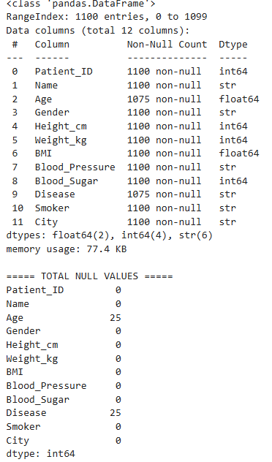
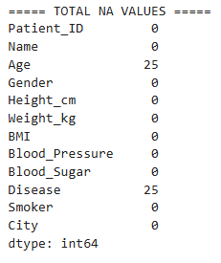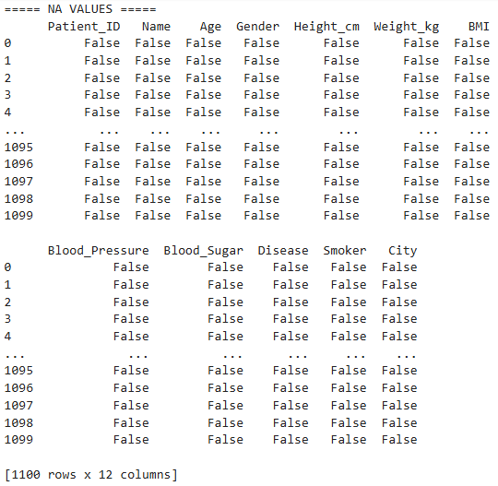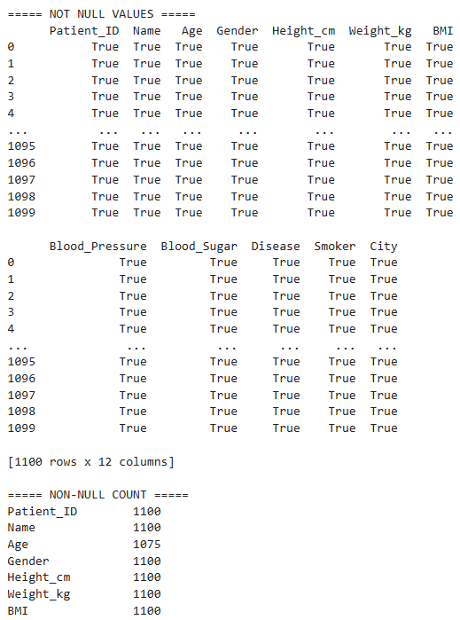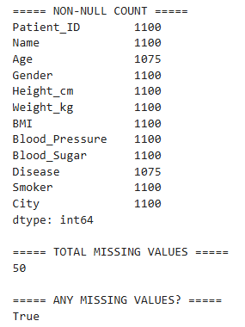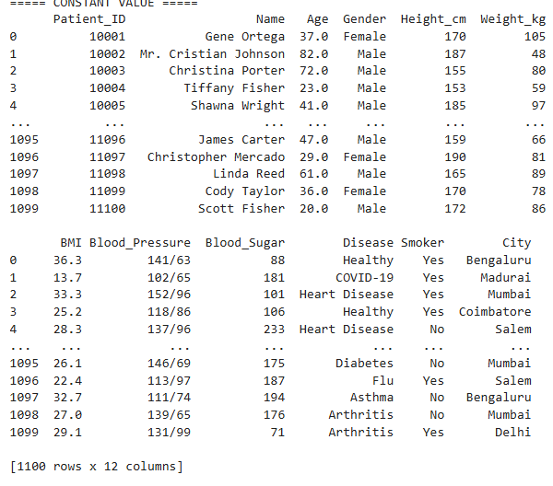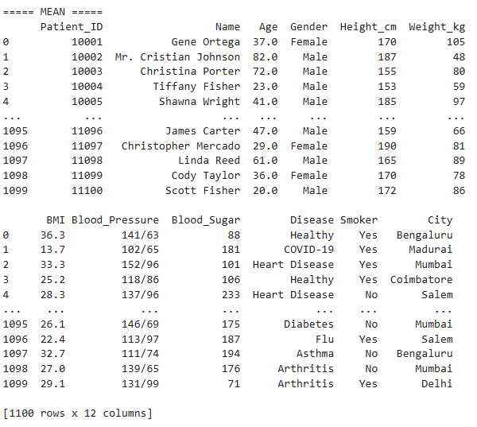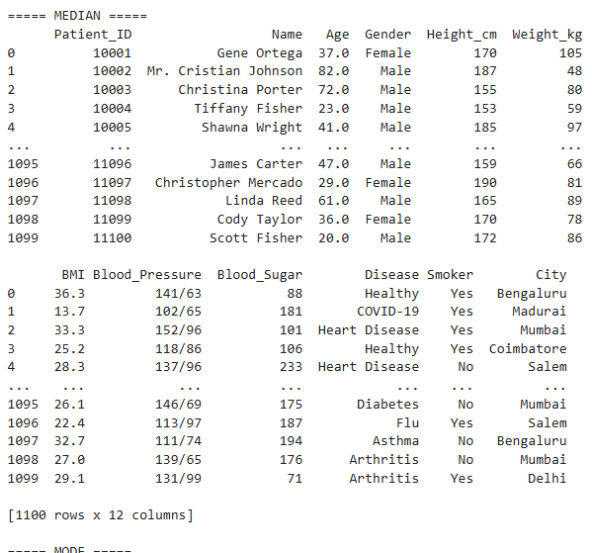

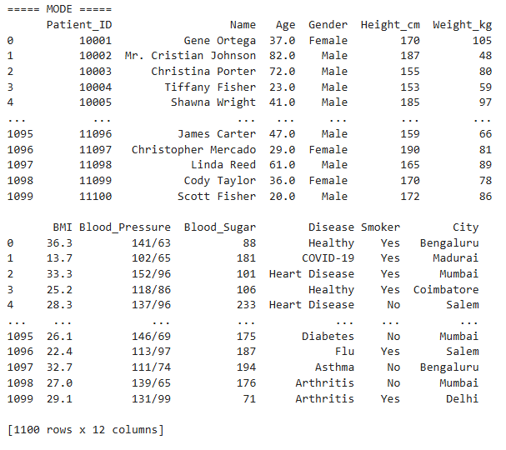
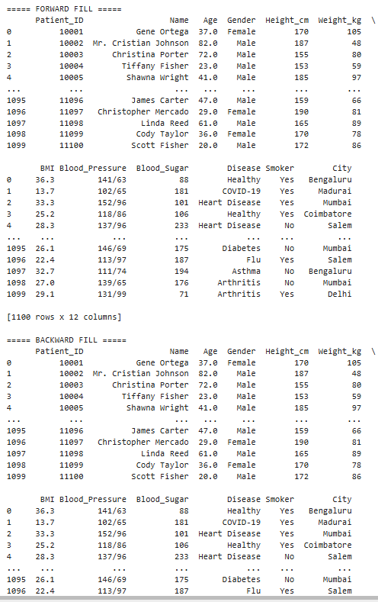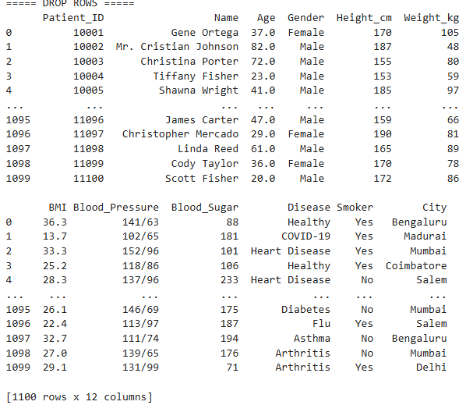

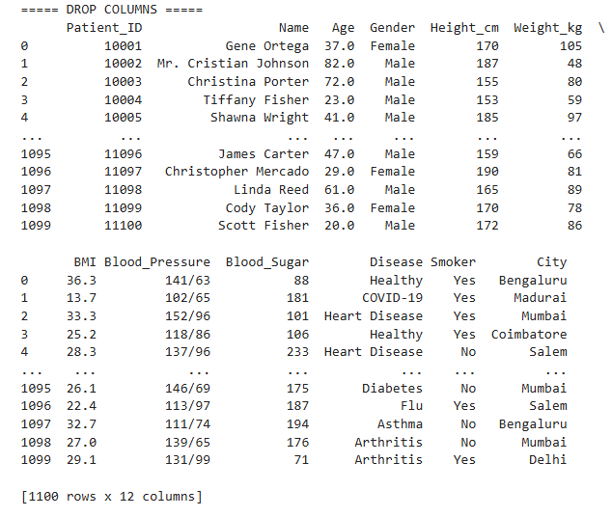
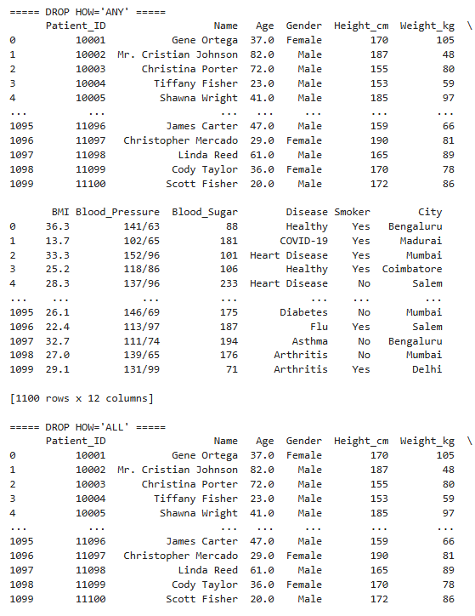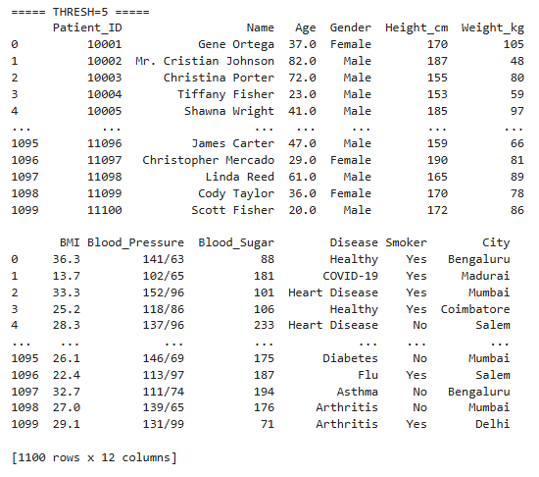

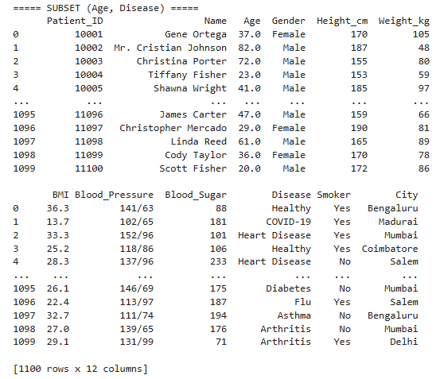
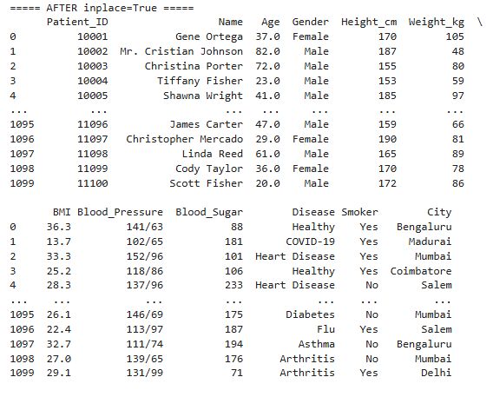

RESULT:
Thus, missing values, duplicate records, and outliers were identified and handled successfully. Data transformation techniques such as normalization and encoding were performed, and the dataset was prepared for further exploratory data analysis and machine learning applications.

